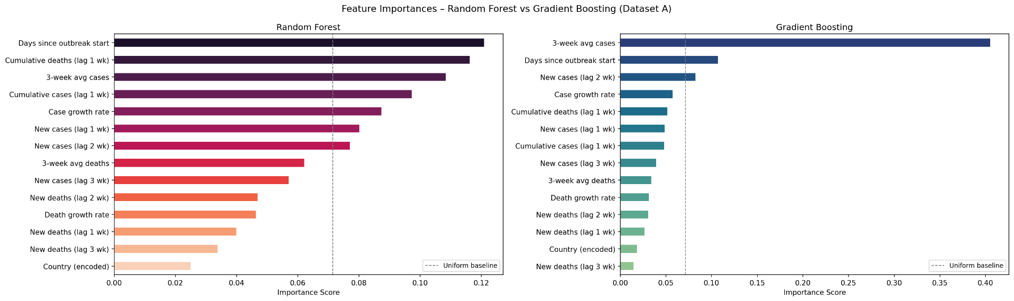
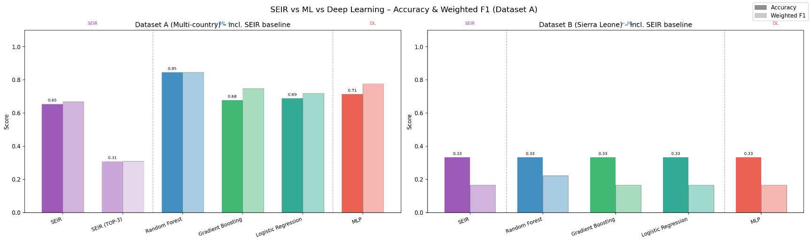
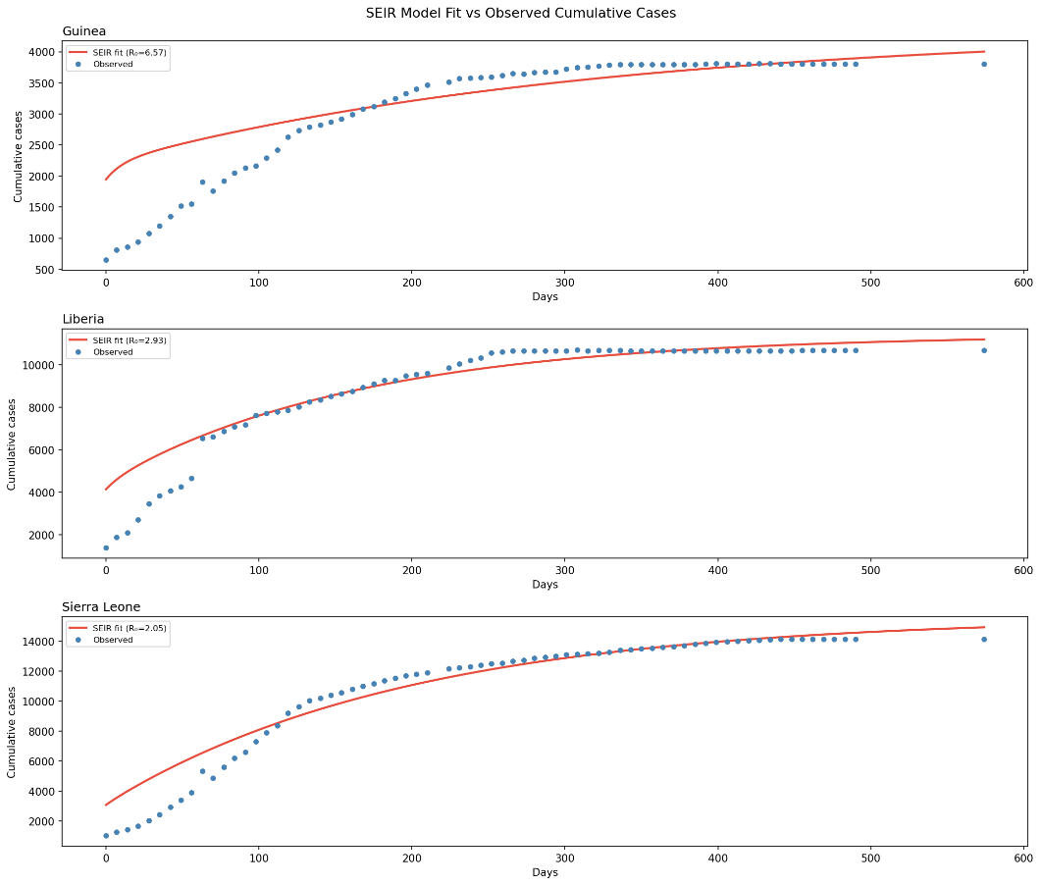
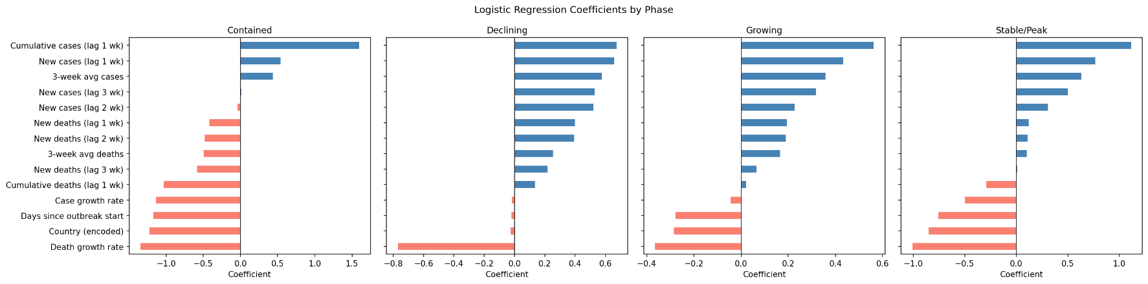
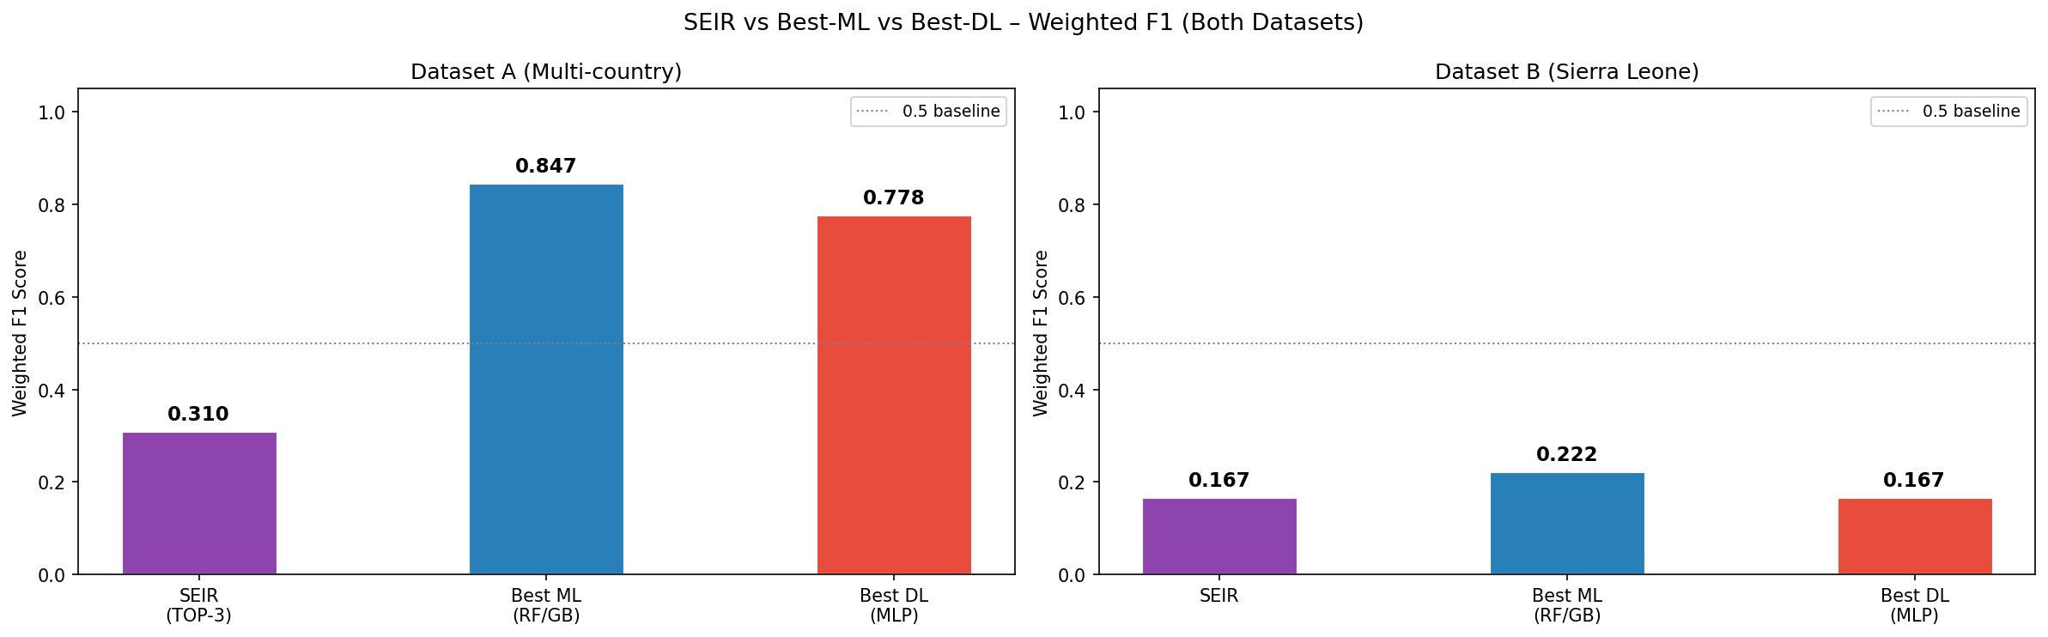
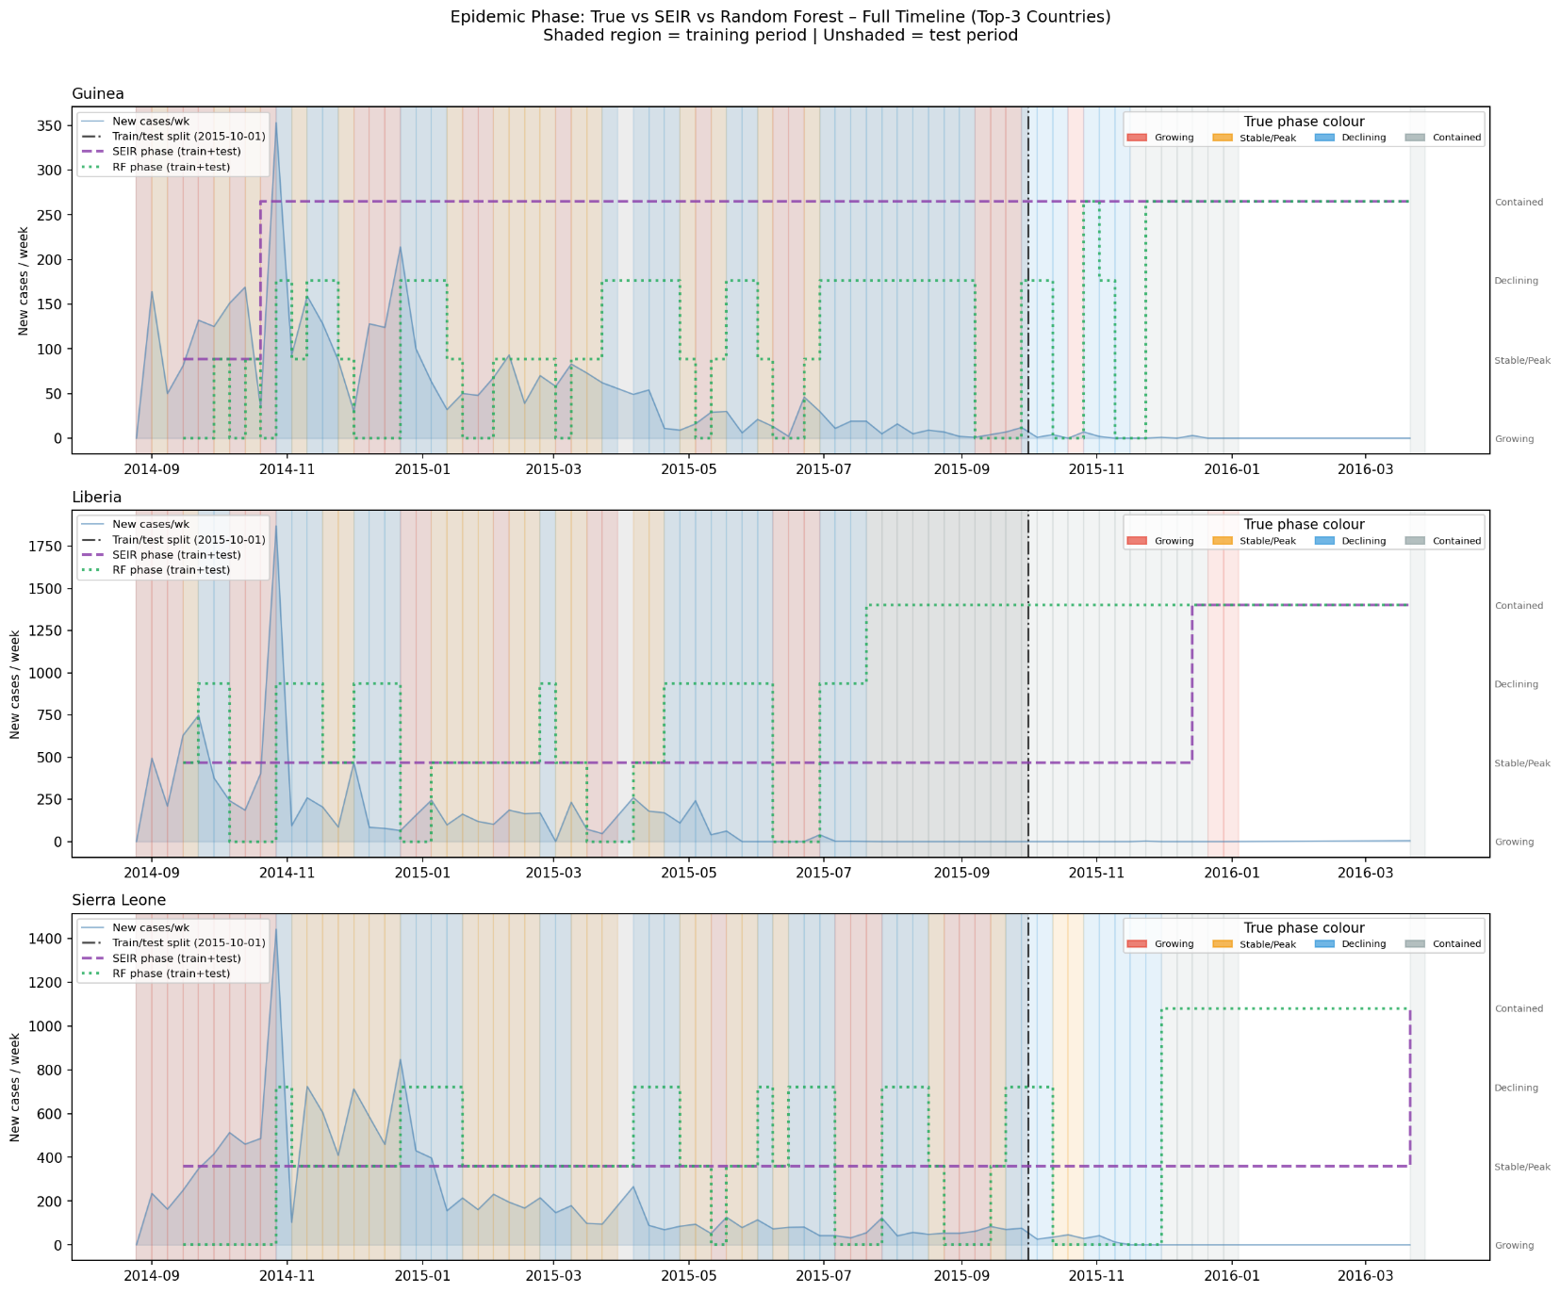
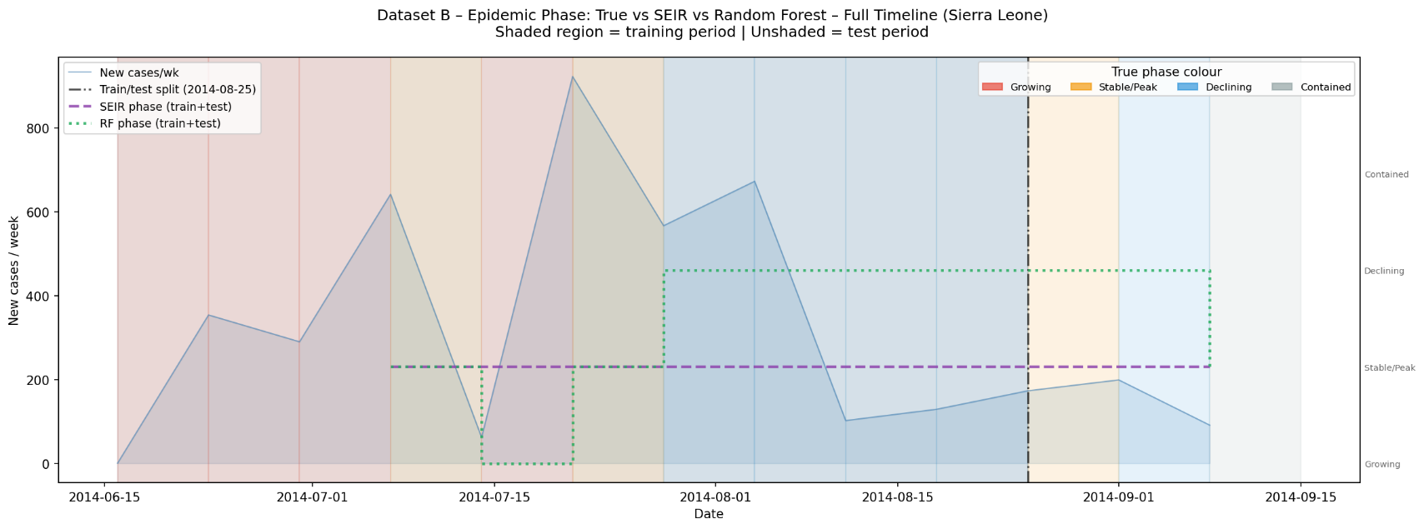
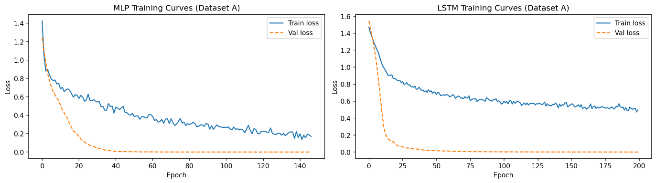

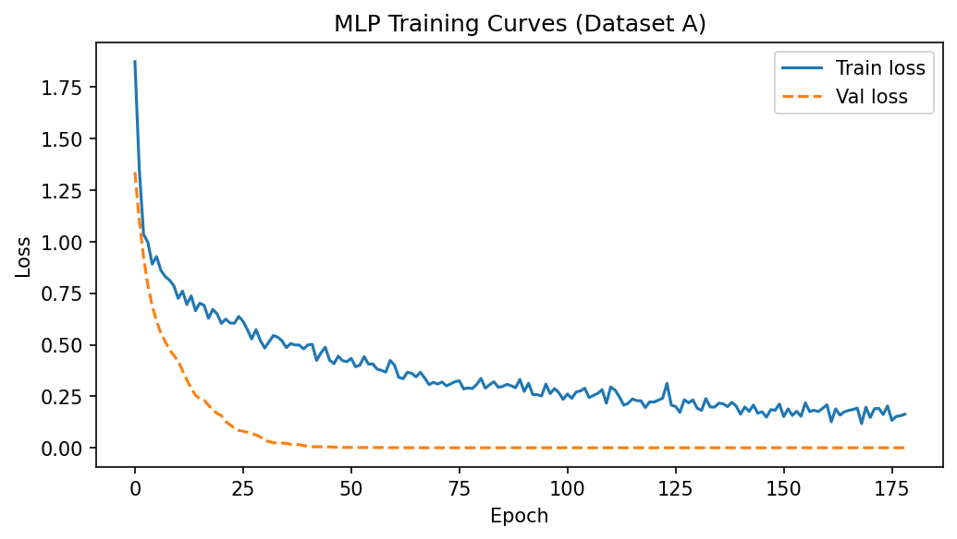

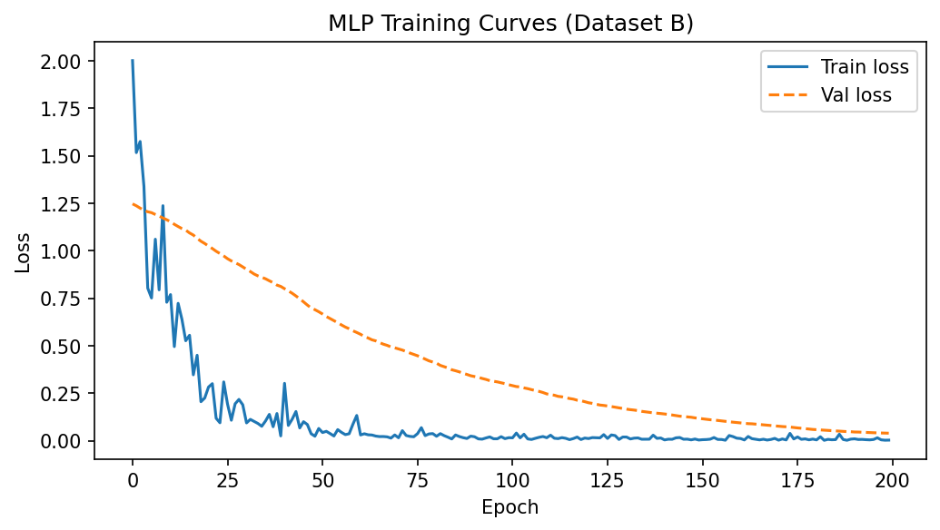

Image 1 — Feature Importances: Random Forest vs Gradient Boosting
What is this graph even showing?
Imagine you're a doctor trying to guess what phase the Ebola outbreak is in. You have 14 pieces of information (features) available to you — things like "how many new cases last week", "how many deaths 2 weeks ago", "how long has the outbreak been going on", etc.
The feature importance chart answers one simple question:
"Which pieces of information did the model rely on the MOST to make its decision?"
The longer the bar, the more that piece of information mattered.

Random Forest (left side)
The top features are:
1. Days since outbreak start (~0.12) — This is the single most useful piece of information. Think about it like this: if someone tells you "we are on day 400 of the outbreak", you already have a strong guess that it's probably Declining or Contained, because outbreaks naturally wind down over time. The model learned this pattern strongly.
2. Cumulative deaths lag 1 week (~0.115) — The total number of deaths so far, from last week. A very high cumulative death count means the outbreak has been going on long and hard — likely past its peak.
3. 3-week average cases (~0.108) — Instead of just looking at one noisy week, this smooths out the last 3 weeks of cases. Smoother signals are easier to learn from.
4. Cumulative cases lag 1 week (~0.097) — Similar idea — the running total of all cases tells you how far into the outbreak you are.
5. Case growth rate (~0.088) — Is the number of new cases going up or down compared to before? This directly captures the direction of the outbreak.
Notice how the bars are spread out fairly evenly — Random Forest shares importance across many features. No single feature dominates overwhelmingly.

Gradient Boosting (right side)
This is where it gets really interesting. Look at the top feature:
1. 3-week average cases (~0.40) — This one feature alone gets 40% of the total importance. That is enormous. Gradient Boosting became almost entirely dependent on this one signal.
2. Days since outbreak start (~0.11) — Same as RF, but much smaller here because GB already extracted so much from feature 1.
3. New cases lag 2 weeks (~0.085) — Cases from 2 weeks ago.
Everything else gets very small bars (under 0.07).
Why is GB so different from RF?
Random Forest builds many trees independently and averages them — so importance gets spread around. Gradient Boosting builds trees one after another, each one trying to fix the mistakes of the previous one. It quickly discovers that "3-week avg cases" is the best single signal and keeps leaning on it heavily in every tree it builds. This is called concentration of importance — GB bets big on fewer features.

Image 2 — Logistic Regression Coefficients by Phase
What is this graph showing?
Logistic Regression works differently from the tree models. Instead of importance scores, it gives each feature a coefficient — a positive or negative number.
Think of it like a voting system:
- Blue bars (positive) = this feature votes FOR this phase
- Red/salmon bars (negative) = this feature votes AGAINST this phase
There are 4 panels — one for each phase the model can predict.

Contained panel (leftmost)
The model is trying to answer: "Is the outbreak contained right now?"
- Cumulative cases lag 1 wk (large blue bar, ~+1.6) — A high cumulative case count SUPPORTS the "Contained" label. This seems counterintuitive at first, but it makes sense: Contained happens LATE in the outbreak, when total cases have already piled up but new cases have stopped.
- Death growth rate (large red bar, ~-1.3) — If deaths are still growing fast, that strongly argues AGAINST containment.
- Days since outbreak start (red bar) — Interestingly negative here, meaning early in the outbreak the model doesn't think it's contained (which makes sense).
Declining panel
- Almost everything is blue (positive) — all case and death lag features support the Declining label when they are present together. The model learned that Declining has a broad signature across many features simultaneously.
- Death growth rate (large red bar, ~-0.7) — Fast-growing deaths contradict a declining phase.
Growing panel
- Cumulative cases lag 1 wk (blue ~+0.55) — surprisingly positive, but cumulative cases keep rising even in Growing.
- Case growth rate (red bar, ~-0.25) — Wait, the growth rate is NEGATIVE for the Growing phase? This seems wrong, but it reflects a modeling quirk: Logistic Regression is linear and sometimes picks up indirect relationships.
- Death growth rate (very large red bar, ~-0.45) — Rapid death growth actually argues against "Growing" here because the model associates explosive death growth with the peak, not the growth phase.
Stable/Peak panel
- Cumulative cases lag 1 wk (large blue ~+1.05) — High total cases supports Stable/Peak.
- Death growth rate and Days since outbreak (large red bars) — These argue against Stable/Peak, meaning very early or very late in the outbreak, Stable/Peak is unlikely.

Image 3 — SEIR Model Fit vs Observed Cases
What is this graph showing?
The red line is what the SEIR mathematical model predicted the total case count would be over time. The blue dots are the actual real reported cases from WHO data.
The x-axis is days since the outbreak started. The y-axis is the total cumulative cases ever recorded.
A perfect model would have the red line going exactly through every blue dot.

R₀ (pronounced R-naught) is the basic reproduction number in epidemiology. It measures the average number of new infections caused by one infected individual in a completely susceptible population, assuming no interventions or immunizations are in place.
Key Concepts
- How Contagious is It?
  - If R₀ < 1, the disease will eventually die out.
  - If R₀ = 1, the disease will remain stable in the population.
  - If R₀ > 1, an outbreak or epidemic is likely to occur.

Guinea (top panel) — R₀ = 6.57
The red line starts very high and stays above the dots for the first 100 days, then the dots catch up. This means the model overestimated early spread but eventually converged.
The R₀ of 6.57 is suspiciously high — for Ebola the real R₀ is typically 1.5 to 2.5. This happened because Guinea's outbreak had a very unusual shape — it spread slowly at first through rural areas, then had bursts of transmission in urban settings. The optimizer couldn't fit this complex shape with a single smooth curve, so it found a mathematically "good enough" but epidemiologically unrealistic R₀.
Liberia (middle panel) — R₀ = 2.93
The fit is much better here. The red line tracks the blue dots reasonably well through the middle of the outbreak. The slight overestimate at the very end happens because Liberia's outbreak declined faster than a pure SEIR model predicts — strong international intervention accelerated the decline.
Sierra Leone (bottom panel) — R₀ = 2.05
The fit is decent overall but consistently undershoots the middle period (roughly days 50–150). During this time Sierra Leone was experiencing a genuine acceleration that the model's smooth curve couldn't fully capture. The R₀ of 2.05 is the most epidemiologically realistic of the three.
The fundamental problem with all three fits: The SEIR model assumes the transmission rate β never changes. In reality, as people changed behaviour, treatment centres were built, and international aid arrived, the effective transmission rate dropped dramatically — something a single fixed β can never capture.

Image 4 — SEIR vs ML vs Deep Learning Accuracy & F1
What is this graph showing?
This is the report card for every model tested. There are two metrics shown side by side for each model:
- Dark bar = Accuracy — out of all predictions made, what percentage were correct?
- Light bar = Weighted F1 — a more careful score that accounts for the fact that some phases appear more often than others in the data
In an Ebola prediction model, a higher F1 score means the model is excellent at identifying actual Ebola patients while avoiding false alarms.
It proves the model is reliable and safe for medical use because it balances two critical goals:
1. It catches the real cases (High Recall)
- What it means: The model rarely misses a sick person.
- Why it matters: Missing an Ebola patient means an infected person goes home, doesn't get treated, and spreads the deadly virus to the community.
2. It minimizes false alarms (High Precision)
- What it means: When the model flags someone as "Ebola Positive," that person almost certainly has the virus.
- Why it matters: If the model constantly panics and flags healthy people as positive, hospitals waste rare isolation beds, scarce protective gear, and limited medical staff on healthy citizens.
Why standard "Accuracy" fails here
Imagine testing 1,000 people in a city, and only 2 actually have Ebola.
- A broken model that just guesses "Everyone is healthy" would be 99.8% accurate.
- However, those 2 sick people would die and spread the virus.
- Because it missed the target completely, its F1 score would be 0.
The Bottom Line
- Low F1 Score: The model is dangerous. It either misses dying patients or floods the hospital with healthy people.
- Higher F1 Score: The model is trustworthy. It accurately finds the sick people without causing chaos and false alarms.

There are two panels — Dataset A (multi-country, left) and Dataset B (Sierra Leone only, right).

Dataset A (left panel) — the meaningful results
SEIR: 0.65 accuracy — The mathematical model gets 65% right. Not bad for something that needs no training data at all and is based purely on equations.
SEIR TOP-3 only: 0.31 — When evaluated only on Guinea, Liberia, and Sierra Leone (the countries it actually has SEIR fits for), it drops to 31%. This is because these three countries had more complex outbreak dynamics that the smooth SEIR curve misclassified.
Random Forest: 0.85 — The best performing model overall. 85% accuracy means it correctly identified the epidemic phase 85 times out of every 100 weeks.
Gradient Boosting: 0.68 — Decent but not as good as RF. Despite its concentrated importance on 3-week avg cases, it doesn't generalise as well.
Logistic Regression: 0.69 — Slightly better than GB, which is impressive given how simple it is.
MLP: 0.71 — The basic neural network does well.
Dataset B (right panel) — the problematic results
Everything scores exactly 0.33. This is not a coincidence — 0.33 is what you'd get if you just guessed randomly between 3 classes. Every single model, from the simple SEIR to the complex MLP, is essentially performing no better than random chance.
Why? Because Dataset B only covers Sierra Leone's very first few weeks of the outbreak (June–August 2014). In those weeks, the outbreak was almost entirely in the "Growing" phase with barely any transitions to other phases. There simply wasn't enough variety in the data for any model to learn meaningful patterns.

Image 5 — SEIR vs Best ML vs Best DL Weighted F1
What is this graph showing?
This is a simplified summary that picks just the best ML model (RF or GB) and best DL model (MLP or LSTM) and compares them head-to-head against SEIR. It uses Weighted F1 score only (the more careful metric).
Dataset A (left)
- SEIR: 0.310 — mechanistic baseline
- Best ML (RF/GB): 0.847 — dramatically better, nearly double SEIR
- Best DL (MLP/LSTM): 0.796 — also excellent, slightly behind ML
The gap between SEIR and ML/DL is enormous — about 0.54 points. This tells you that the hand-crafted features (lag cases, lag deaths, growth rates) give ML models information that the SEIR mathematical structure simply cannot exploit.
Dataset B (right)
- SEIR: 0.167
- Best ML: 0.222 — marginally better
- Best DL: 0.167 — same as SEIR
All three are terrible. Even the best ML model barely edges out SEIR. The 0.5 dotted baseline (what a reasonable model should beat) is completely out of reach for all models on this dataset. This confirms that Dataset B's problem is fundamentally about too little data and too little phase diversity, not about which model you pick.

Image 6 — Epidemic Phase Timeline Dataset A (Top 3 Countries)
What is this graph showing?
This is the most information-rich graph of the whole project. For each country there are three things shown:
- Background colours = the TRUE phase each week (red=Growing, orange=Stable/Peak, blue=Declining, gray=Contained)
- Purple dashed line = what the SEIR model predicted the phase was
- Green dotted line = what Random Forest predicted
- Blue shaded area + line = the actual weekly new case numbers
- Vertical black dashed line = the train/test split (October 2015) — left of this was used for training, right is the real test

Guinea (top panel)
The true phase (background) switches very frequently — Growing, Declining, Stable/Peak alternating rapidly — reflecting Guinea's messy and oscillating outbreak.
The SEIR line (purple) is almost completely flat throughout the whole timeline, stuck at "Stable/Peak" level. This is because SEIR produces one smooth bell-shaped curve and can only predict phase transitions once — it goes Growing → Stable/Peak → Declining in a single arc, never reversing. When the true outbreak oscillates back and forth, SEIR gets it wrong most of the time.
The RF line (green dotted) jumps around much more, trying to follow the true phase transitions. It gets many right but also makes rapid oscillations that don't match — this is RF responding to noisy weekly case counts.
After October 2015 (unshaded test period), the true phase is Contained. SEIR stays at Stable/Peak — wrong. RF eventually catches Contained but also predicts some Declining weeks intermixed.
Liberia (middle panel)
Liberia had a more textbook-shaped outbreak — one big wave peaking around late 2014, then declining. The SEIR line stays at Stable/Peak for most of the training period, misses the transition to Declining, then suddenly jumps to Contained in the test period — but the true phase was actually Growing (a late resurgence) before settling to Contained.
RF does better at tracking the declining phase but also misclassifies the late Growing period.
Sierra Leone (bottom panel)
Sierra Leone had the longest and most sustained outbreak. The SEIR line stays flat at Stable/Peak almost the entire time — it never predicts Growing or Declining at any meaningful scale. RF bounces around tracking the oscillations better, and in the test period correctly predicts Contained for most weeks.

Image 7 — Epidemic Phase Timeline Dataset B (Sierra Leone Early Period)
What is this graph showing?
This is the same type of chart as Image 6 but zoomed into just the first 3 months of Sierra Leone's outbreak (June to September 2014) using the more granular Dataset B.
The train/test split here is August 25, 2014 — so the training set is only about 10 weeks of data.
The true phase background shows rapid changes: Growing → Stable/Peak → Growing → Declining → Stable/Peak → Declining → Contained — all in just 3 months. This is extremely volatile for such a short period.
The SEIR line (purple) predicts Stable/Peak for the entire period — completely flat and completely wrong for most weeks. With only a few weeks of data to fit, SEIR locks onto a single phase and stays there.
The RF line (green dotted) briefly drops to Growing in mid-July when new cases spiked up, then jumps to Declining when they dropped, then back up. It catches some transitions but misses the final Stable/Peak → Declining → Contained sequence entirely.
This graph visually explains exactly why Dataset B scored 0.33 on everything — the data is so short and chaotic that neither model can learn reliable patterns. There simply aren't enough examples of each phase for the model to understand what each one looks like.

Image 8 — Training Curves Dataset A ,MLP
What is training loss and validation loss?
When a neural network learns, it sees training data repeatedly and tries to get better at classifying it. After each pass through the data (called an epoch), we measure two things:
- Train loss (blue solid line) — how many mistakes the model makes on the data it's learning from. This should go down as the model learns.
- Validation loss (orange dashed line) — how many mistakes the model makes on data it has NEVER seen before (a held-out 15% of the training set). This tells you if the model is actually learning general patterns or just memorising.
A good model has both lines going down together and meeting at a low value.

MLP on Dataset A
The train loss (blue) starts high and slowly, noisily decreases over 150 epochs — taking a long time to learn.
The validation loss (orange) drops to near zero almost immediately by around epoch 20 and then stays flat near zero for the entire rest of training.
This looks great at first — the validation loss is very low! But look at the gap: train loss is still at ~0.2 while validation is at ~0.0. This giant gap means the model is overfitting — the 15% validation set happened to be easy examples that the model figured out early, while the training data contains harder patterns it's still struggling with.
This happens because Dataset A is small — with very few data points, the random 15% split can end up with unrepresentatively easy examples in the validation set.

Image 9 — Training Curves Dataset B ,MLP
MLP on Dataset B
This is almost the opposite of Dataset A. The train loss (blue) crashes very rapidly to near zero by epoch 25. The validation loss (orange) decreases much more slowly, only converging around epoch 175–200.
Here the training set is tiny (only ~10 weeks), so the MLP memorises it almost immediately. The validation set (15% of those 10 weeks — basically 1 or 2 data points) is harder and takes longer to fit. They eventually converge, which is the healthy sign.
The paradox of Dataset B
Here's the strange part: Dataset B's training curves look healthier than Dataset A's, yet Dataset B scored only 0.33 (random chance) while Dataset A scored up to 0.71.
The reason is that healthy training curves only mean the model learned the training data well. If the training data itself has no useful phase diversity (because the outbreak was almost entirely Growing for the whole period), there are no meaningful patterns to learn — and even a perfectly trained model will fail on the test set.
Good training curves + bad test performance = the data was the problem, not the model.


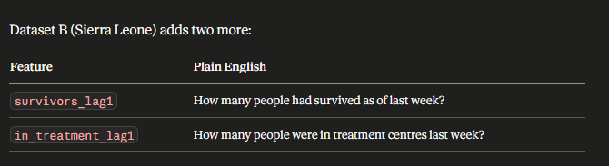
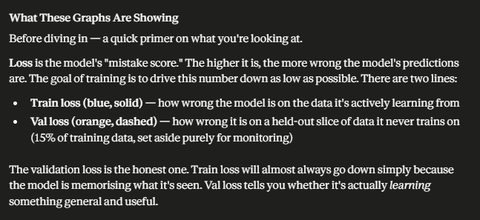
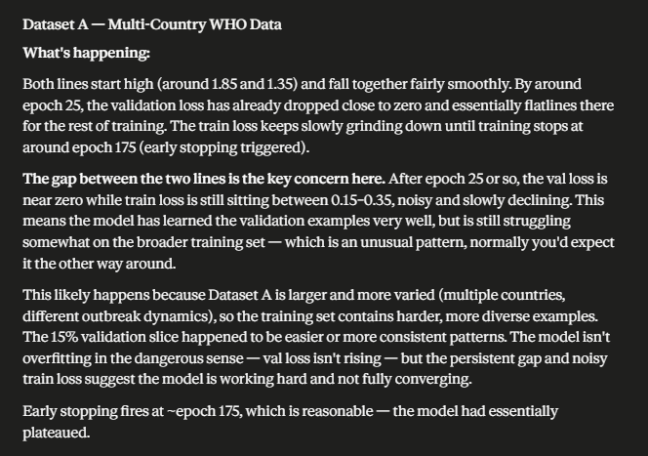
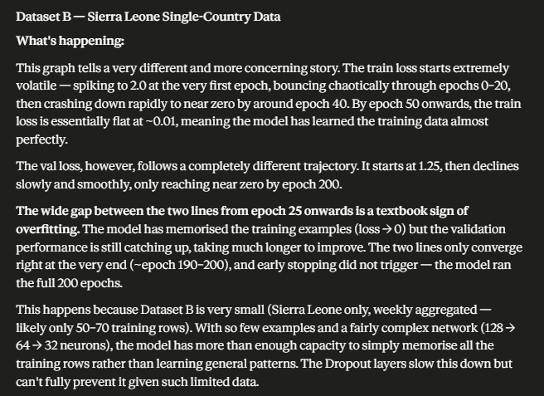
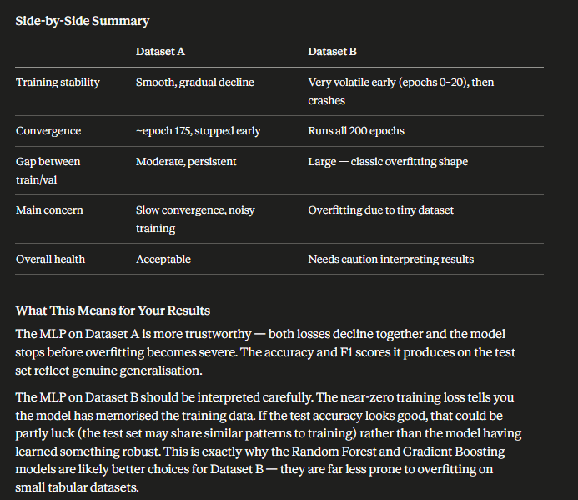

The Big Picture Summary
Graph | The one thing it tells you
Feature Importances | Time into outbreak and cumulative burden matter most; GB bets everything on one feature while RF spreads the load
LR Coefficients | Each phase has a unique combination of positive and negative signals
SEIR Fit | The mathematical model fits the general shape but misses real-world complexity because transmission rates changed over time
Accuracy comparison | RF wins on Dataset A; everyone fails equally on Dataset B
F1 summary | ML is nearly 3× better than SEIR on Dataset A; Dataset B is hopeless for all models
Timeline A | SEIR is dangerously rigid (flat line); RF is noisy but responsive
Timeline B | Too little data, too chaotic, too short — no model can win here
Training curves A | Models overfit because the dataset is small
Training curves B | Models train well but the data has nothing useful to teach them

